UML - Class Diagrams

Project: EasiLendar

The Very Best Meeting Planer

Creator: Nguyen Minh Trang

Last update: 07/05/2015

Table of Contents

I. Factory - Factory diagrams 3

II. Class – Class diagrams 4

1. Classes defined in “eEasiLendar” factory 4

2. Classes defined in “eTimeHeap” factory 5

3. Classes defined in “eMultiCalendar” factory 5

III. Controller – Factory diagrams 6

1. SignInController 6

2. sideMenuController 7

3. WeekController 8

4. friendPanelController 9

5. ListController 10

6. LoadingController 11

7. SearchController 12

8. EditEventController 13

9. EventDetailController 14

10. ResultController 15

11. PopOverController 16

12. ShareController 17

# I. Factory - Factory diagrams

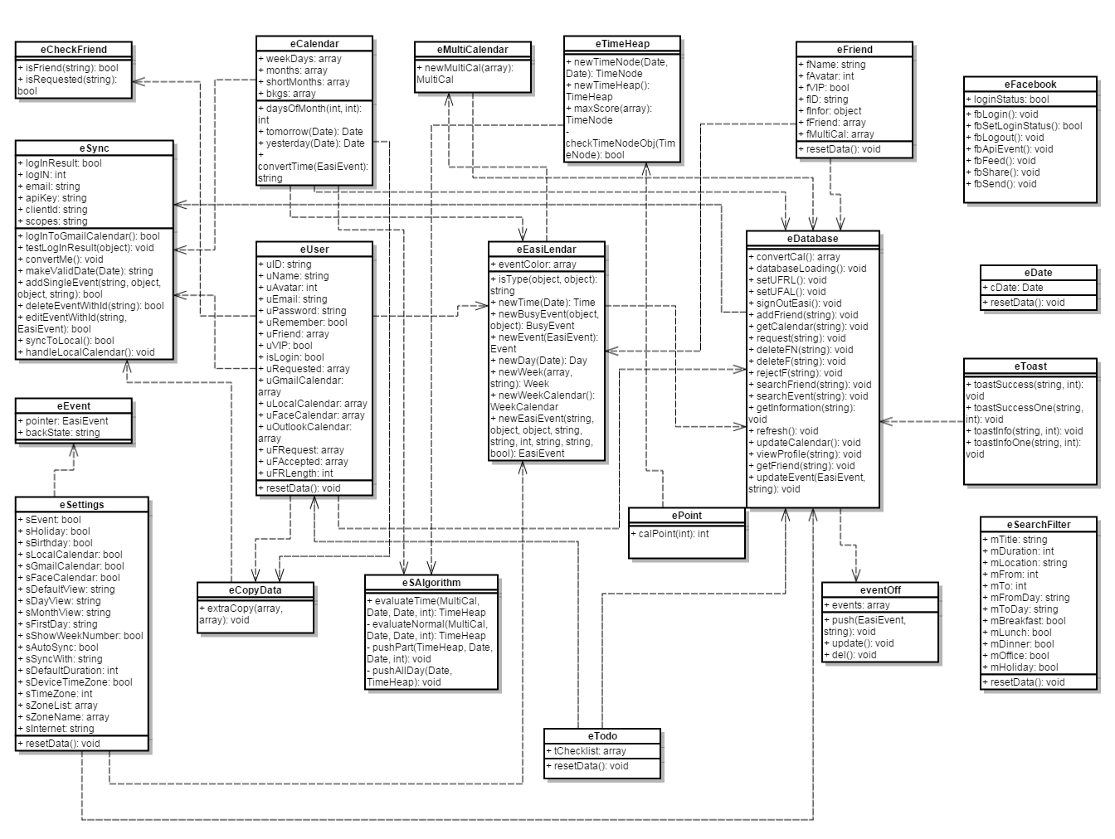

# II. Class – Class diagrams

## 1. Classes defined in “eEasiLendar” factory

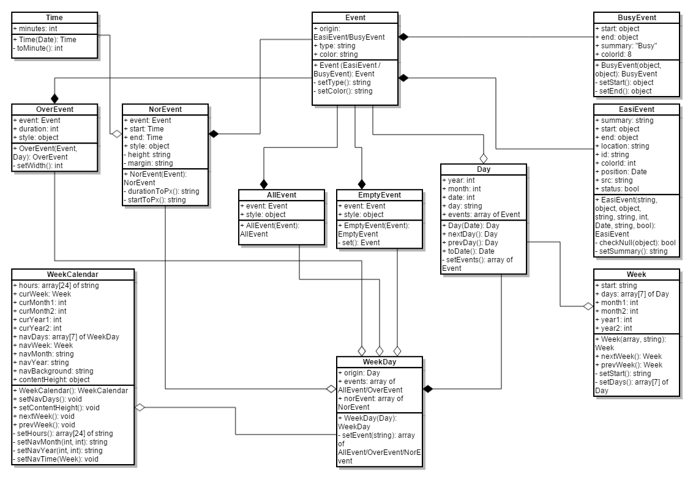

## 2. Classes defined in “eTimeHeap” factory

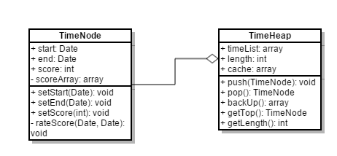

## 3. Classes defined in “eMultiCalendar” factory

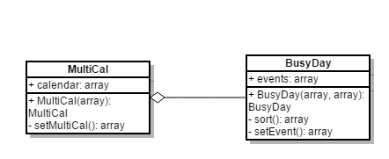

# III. Controller – Factory diagrams

## 1. SignInController

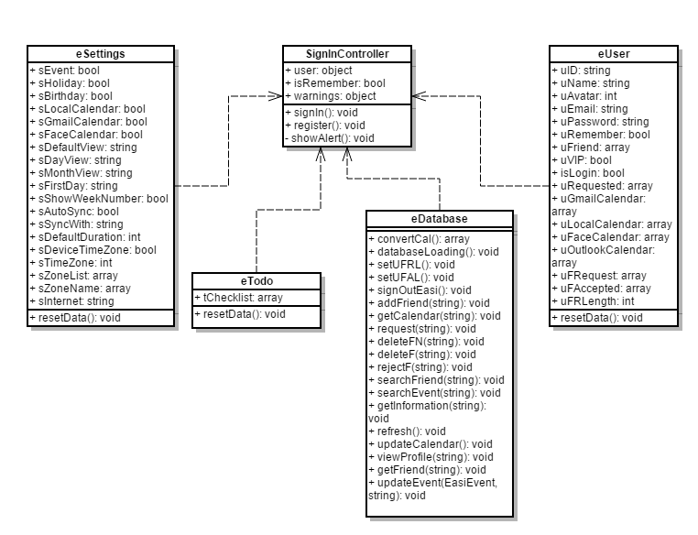

## 2. sideMenuController

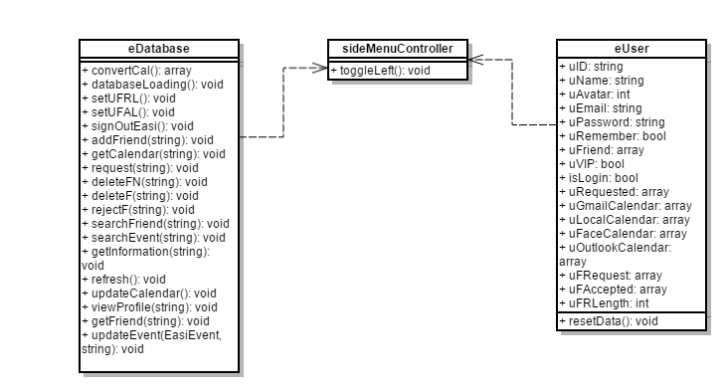

## 3. WeekController

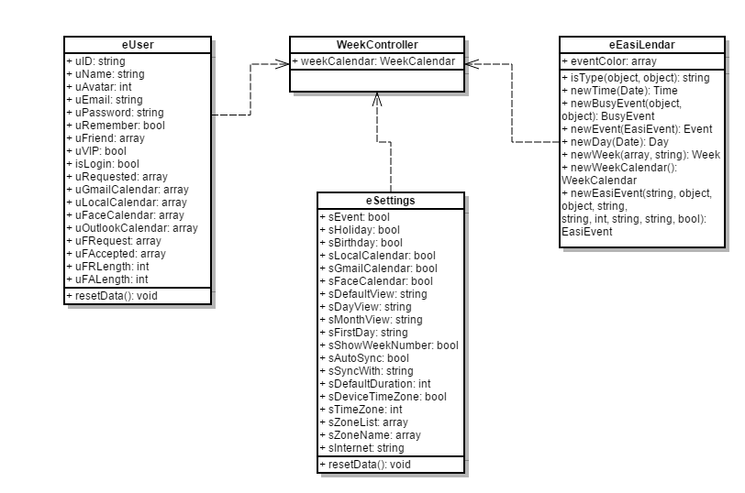

## 4. friendPanelController

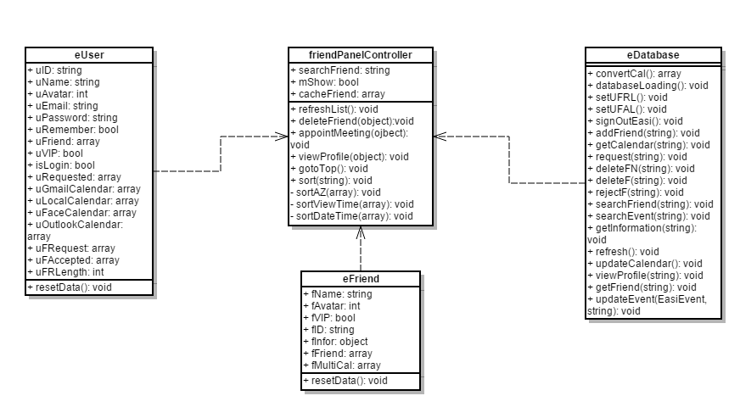

## 5. ListController

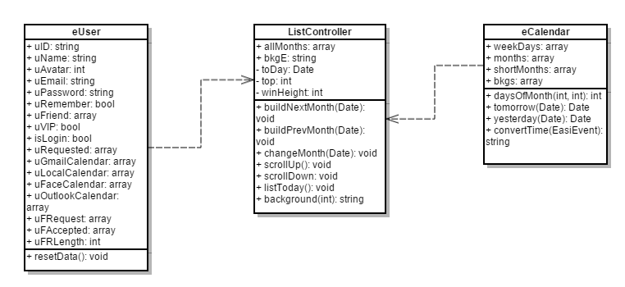

## 6. LoadingController

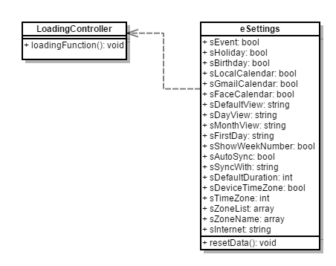

## 7. SearchController

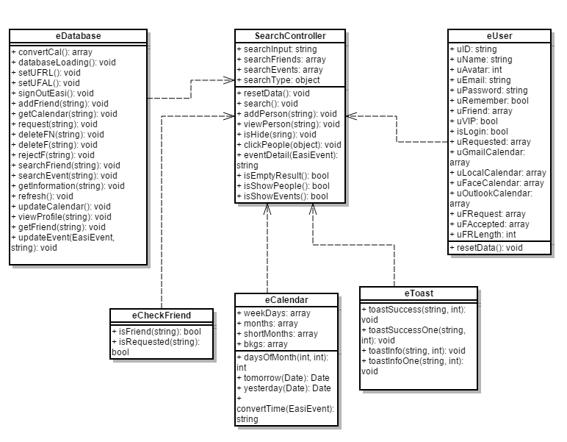

## 8. EditEventController

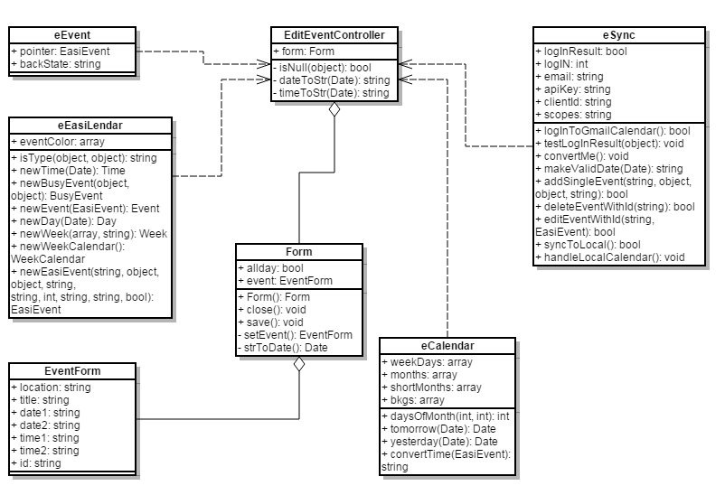

## 9. EventDetailController

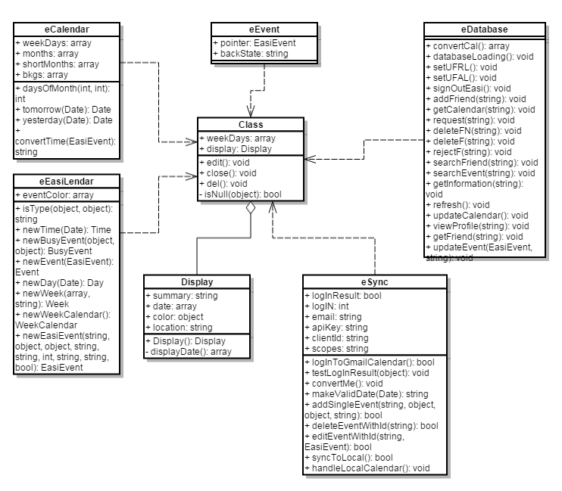

## 10. ResultController

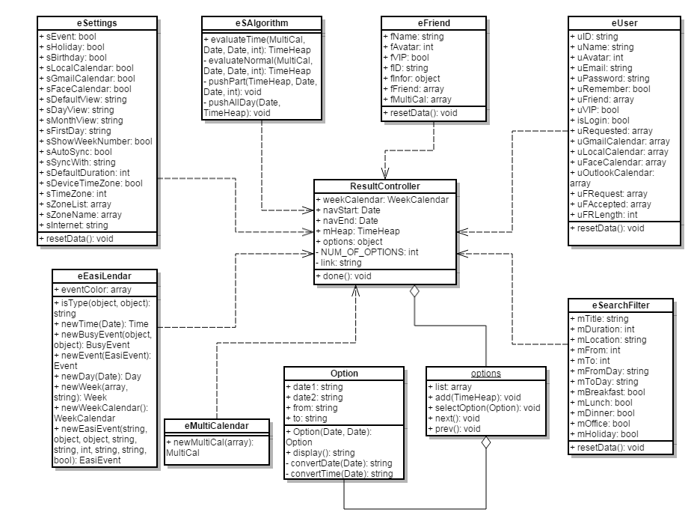

## 11. PopOverController

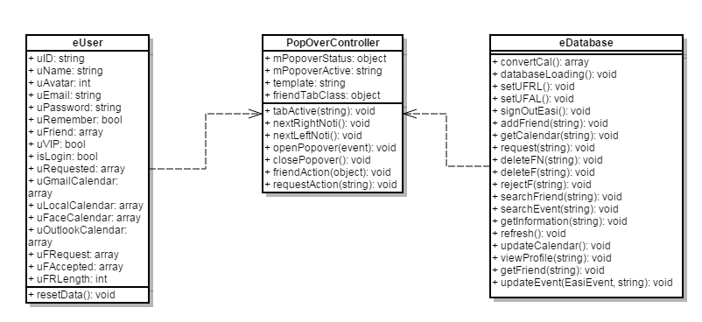

## 12. ShareController

